**Journey Through The Bible**

**Nicodemus**

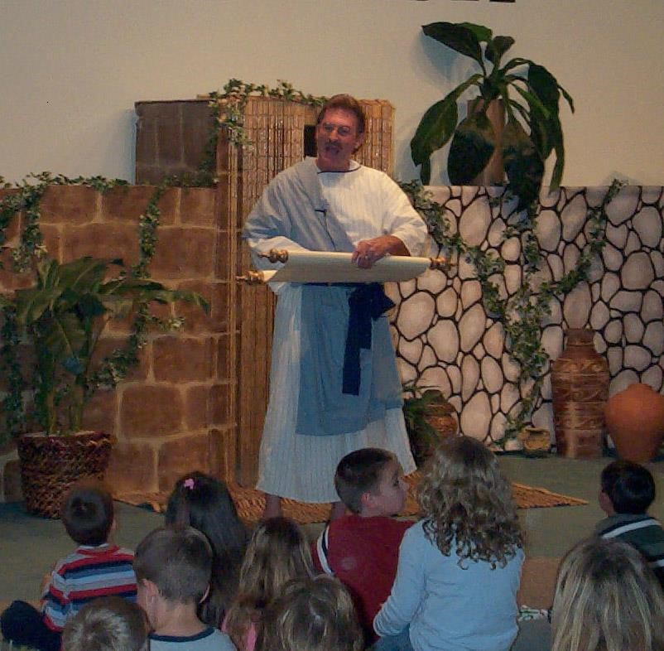

Hello, I’m Nicodemus, a Pharisee and a member of the Sanhedrin. The Sanhedrin is a ruling Council of the Jewish people. I don’t mean to sound boastful, but is a powerful position and you are considered by many to be important if you are a member of this Council. But we are often criticized by Jesus, John the Baptist and others for our actions and beliefs.

I had heard about Jesus and his teachings for some time and it was very interesting to me. However, because of my position, I had to keep it a secret. I would have been ridiculed by my fellow members if they thought I was a follower of Jesus. I wanted to learn more about him. I knew that Jesus was in Jerusalem for the Passover Feast, so I arranged for a meeting with him at night so that no one else would see me.

At this meeting I told Jesus that I believed that he was a teacher sent from god because no man could perform the miraculous things he did if God were not with him.

Jesus said to me, “No one can see the Kingdom of God unless he is born again.” I didn’t really understand the meaning of this. So I asked Jesus, “Can a man be born again when he is old?” Jesus then said, “No one can enter the Kingdom of God unless he is born of water and of the spirit.” I asked again, “How can this be?” Jesus answered, “You are a teacher of Israel and do you not understand these things?”

He continued to speak about his teachings that people would not believe. He mentioned Moses lifting up the snake in the desert and said the Son of Man must be lifted up, that everyone who believes in him may have eternal life.

I left that meeting with a stronger belief than before and made a commitment to continue to learn more about his teachings.

I even stood for him in a meeting of the Council when I asked, “Does our law condemn anyone without first hearing him to find out what he is doing?” That was a bold move for me and a great risk. I continued to grow stronger in my faith and challenged others who were critical of Jesus.

I was there the day they took Jesus body down from the cross. I went with Joseph of Arimathea to ask Pontius Pilate for the body of Jesus. We wrapped the body with spices and linen because it was a

Jewish burial custom. We laid His body in a new tomb, in a garden.

It was the greatest honor of my life.

If you want to read more about me, open your Bibles to the book of John. Now I want to ask you some questions. (Prepare some questions about your character.)

**Scripture reading**: John 3:1-17 and 19:38-42

**Memory Verse:** John 3:16

For God so loved the world that He gave His only begotten Son, that whoever believes in Him should not perish but have everlasting life